**AEE 342: Aerodynamics, Project 2b – Analysis of Non-symmetric Airfoil Flows**

**Submitted: 02/27/15**

There are many different flow conditions that can be simulated and observed around an airfoil, but certain flows are of particular interest when evaluating its flight performance. Namely, the superposition of uniform rectilinear flow (URF) with vortex flow is largely responsible for the generation of lift and drag, some major indicators of airfoil performance. However, other types of flows are typically modelled over airfoils in order to satisfy some conditions, or to obtain certain data. In this investigation, the goal is to compute the pressure distribution over different airfoils at different angles of attack through a superposition of URF, source flow, and vortex flow. Several different ways to define these flows under conditions consistent with theory are evaluated, as too are the assumptions necessary for such conclusions. The analysis to follow will aim to properly formulate the problems under consideration, to model them on a theoretical basis, and to evaluate the assumptions made in the process.

The first task is to prepare the geometry of the airfoil so that it can best be shown to satisfy physical principles. Namely, this refers to the Kutta Condition which can be represented well on an airfoil with a wedge-shaped trailing edge. The given thickness distribution for a NACA 4 digit airfoil describes an airfoil with a trailing edge that is blunt and does not end precisely at x = 1. Several modifications can be made to enforce this condition. Since it is desired that the surface of the airfoil be differentiable, it would be best to modify the equation itself so that it behaves as desired. The original thickness distribution is given by

Where is the maximum thickness of the airfoil as a percentage of chord length. In order to come to a point at the trailing edge, the thickness must define a point at the coordinate (1, 0). Plugging this condition into the thickness distribution yields

And further

From here, it is clear that one of the coefficients must be altered so that this condition is made true. Since x will always be less than 1, the best coefficient to choose would be the fifth one because it would have the lowest overall weight, particularly at low values of x. Therefore

Thus yielding the new thickness distribution

These two distributions are plotted below for comparison. The two figures are of the same data, but the one on the right is scaled so that the distinction between the two airfoils at the trailing edge can be exaggerated.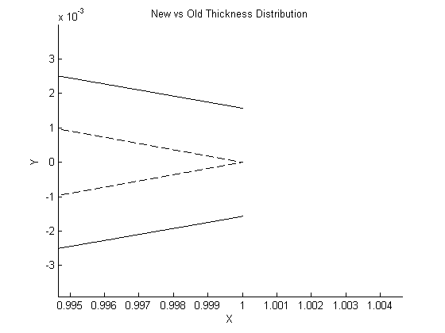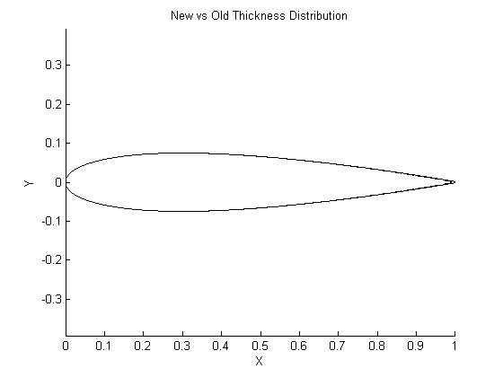 The solid line is of the old data and the dashed one is of the new. Visually, it is clear that the new thickness distribution satisfies the posed requirement and does not appear to deviate substantially from the definition of the NACA airfoil. This is reaffirmed by some quantitative analyses used to measure the two airfoils. The two geometries consistently had the same maximum thickness and the point was nearly always located at the same value of x. Only after plotting the geometry that would correspond to a system of 10000 panels did the index of the maximum thickness shift by one point. For a hypothetical airfoil with a chord length of 1 meter, this would shift the point of maximum thickness by only 0.2 mm. This result falls within a very reasonable margin of error, especially for the purposes of this investigation.

With the geometry prepared, the vortices may be superimposed into the flow. First, a single point vortex may be placed. The best place to apply this single vortex would be at . Since vortex components are derived in polar coordinates, it is best to place the vortex at the leading edge in order to simplify the conversion to a Cartesian coordinate system. After this, a simple shift of coordinates can be performed to move the vortex wherever is desired. Generally, for multiple vortices, the positioning of each should maintain a consistent spacing and be located along the camber line. This is so that the vorticity distribution is kept relatively consistent. Additionally, the vortices should be placed near the midsection and leading edge of the airfoil, since this is where the greatest strength is needed. For this reason, 4 vortices can be placed at 0.1c, 0.2c, 0.3c, and at 0.4c to account for these general tendencies of airfoils and the flow around them. A fewer or greater number of vortices can be applied with a similar distribution. If a vortex sheet is to be used, then a panel method should be adopted to discretize the strengths along the airfoil surface. This will generally yield a better solution because it can be used to constrain the flow based on the geometry of the airfoil. Additionally, it will provide a much smoother distribution of vortices and allow for the easy computation of several other useful values such as the velocity along the surface of the airfoil. However, there are some other changes that will make the implementations of these two methods quite different.

One very important part of the implementation of flows around a surface is the set of geometry integrals. These define the nature of the interaction between the flow and the airfoil surface by introducing it as an impenetrable object. This condition is enforced by making all velocities normal to the airfoil surface equal to zero. Specifically, it is applied by taking the partial derivative of the component normal to the surface of the velocity potential, yielding the velocity normal to the surface. For the superposition of URF with source flow as found in the source panel method, this is represented as

By adding vortex flow to the system, the equation becomes

This is the superposition of the three flows satisfying the geometry and calculating the velocity everywhere. A very similar equation would be used for a point vortex by adding a single value instead of a sum.

Next, it is necessary to determine the location of the stagnation point at the trailing edge. For the case of a symmetric airfoil for which , this solution is trivial; the stagnation point lies exactly at the trailing edge at coordinate (1, 0). However, theoretical knowledge of this condition can help to validate the results of numerical methods used to determine the stagnation point systematically for this case and for all other cases. One such way to approach this problem would be to find the point near the trailing edge at which the total velocity is equal to zero, or is closest to zero if there is no point plotted exactly at the stagnation point. This can be done with the help of the find( ) function in Matlab. This function is used to find indices within arrays and can be set to find certain indices with certain conditions. Therefore, if starting from positive values of velocity, the find( ) function can be set to find indices that satisfy the condition that the velocity is greater than or equal to zero. The last value of this set will be either the index of the stagnation point or the index of the point right next to it. An example of this is

indexStagnation = find(V >= 0, 1, 'last')

This is useful because the value returned can be used to index to the value of any array corresponding to the stagnation point.

Once the stagnation point is computed for several cases of airfoil and angles of attack, it can be seen that the stagnation point shifts from the trailing edge in the absence of vortex flow. Physical principles dictate that the stagnation point always remain at the trailing edge, so a circulation is naturally introduced to uphold this condition known as the Kutta Condition. Once a vortex, several vortices, or a vortex sheet have been placed, the Kutta Condition must be satisfied to solve for the correct strengths. However, the methodology here between point vortices and vortex sheets is very different. In the case of a point vortex or point vortices, a single unknown strength is solved for with one equation which satisfies the Kutta Condition. Since only one such condition exists, the strengths of all point vortices must be the same so that the problem can be solved. The relation used here is based on the fact that the total velocity at the trailing edge must be zero. By summing up all superimposed flows and setting them equal to zero, a satisfactory relation is made using the same number of equations as unknowns. This relation is

In the case of a vortex sheet, the Kutta Condition is applied by setting the strengths of the two panels adjacent to the trailing edge equal and opposite to one another. However, this gives one more equation than there are unknowns, so one panel on the airfoil must arbitrarily be disregarded so the Kutta Condition can be applied to another one. When implemented, this will force the velocities on both sides of the trailing edge to be equal and going in the same direction, thus forcing the Kutta Condition.

Finally, in order to make use of the analysis made and to evaluate the performance of the airfoil, the coefficients of lift and drag must be calculated. Two ways this can be done include the use of vortex strengths and the use of pressure coefficients. The former involves first summing up all the vortex strengths to determine the total circulation. From this circulation and other known values, the Kutta-Joukowski theorem can be applied to determine the lift per unit span as follows

From here, the coefficient of lift can be calculated by

Alternatively, coefficients of normal and axial forces can be computed from pressure coefficients and transformed trigonometrically to coefficients of lift and drag. These are given by the following equations

This applies only for inviscid flow since an additional component would be added to each equation to account for skin friction in the case of viscous flow. These then yield

One issue, however, is that the data for pressure coefficients is not continuous and is therefore not integrable. This is not particularly problematic because numerical methods can be used more easily and are more appropriate. The quadrature can be estimated as the difference of the areas under the two pressure curves corresponding to the two surfaces of the airfoil. For , this is computed with respect to x, and for , values can either be transformed to another axis, or it can be taken with respect to y. Once all these values are calculated and the desired results are obtained, all that remains is to evaluate the performance of the airfoils in different conditions and to evaluate the efficacy of the methods used to obtain the results, as described above.

**References**

Anderson, John D. Fundamentals of Aerodynamics. Boston: McGraw-Hill, 2011. Print.

Matlab Documentation. <http://www.mathworks.com/help/matlab/>.